MINUTES OF THE MEETING
Arkansas Financial Education Commission
Wednesday, April 6, 2022, at 11:30 AM
Victory Conference Room and Zoom

The fourth meeting of the Arkansas Financial Education Commission was held Wednesday, April 6, 2022, at 11:00 AM at the Victory Conference Room. Present at the meeting were Treasurer of State Dennis Milligan; Grant Wallace, Chief Deputy Treasurer; John Ahlen, serving as proxy for Susannah Marshall, Commissioner of the State Bank Department; Duncan Bellingrath with the Arkansas Bankers Association; Campbell McLaurin, Interim Commissioner of the State Securities Department; Steve Brown, President and CEO of Alcoa Community Federal Credit Union; Patricia Ashanti, Founder and CEO of Delta Circles; Marsha Masters, Associate Director of Economics Arkansas; Fran Jansen, Director of 529 Programs and Financial Education; and Thomas Burchfield, Manager of Financial Education.
Treasurer of State Dennis Milligan called the meeting to order at 11:31 AM.
Treasurer Milligan opened the meeting by presenting for approval minutes from the February 10, 2022, meeting. Marsha Masters made a motion to approve; it was seconded by Patricia Ashanti and the motion passed.
Next, Treasurer Milligan invited everyone to introduce themselves.
Next, Fran Jansen gave a brief overview of the reception being held at 1:30 p.m. at the Capitol. She also mentioned the Governor’s proclamation of April being named Financial Education Awareness month.
Additionally, Fran updated the board on the AFEC Rules that were approved by the Governor’s office and that they are now in the comment period phase and that we are waiting to present before Admin Rules Subcommittee either in May or June.
Fran then spoke on the CALS Financial Education Series that will be held the months from April to June and then September to November. She also thanked Abby, Patricia, and Susannah for helping find speakers for each of the lessons.
Next, Fran updated the Commission on the status of the Non-Profit filing. She then spoke on the creation of the Commission’s website, saying that we as a office would set it up where it could be reviewed and have feedback from the members.
After this, Fran shared research from the Council of Economic Education. Marsha Masters commented on this, saying the survey was well done every two years. It gives a broad state of affairs when it comes to financial literacy standards in each state. Secretary Key spoke on how these financial literacy standards affected and were applied to the school districts.
Patricia shared a tool to help people to understand investment apps like Robinhood.
The date for the next commission meeting was tentatively scheduled for August, after approval through email from the members.
There being no further business, Treasurer Milligan made a motion to adjourn. The meeting was adjourned at 11:58 AM.
Respectfully submitted,
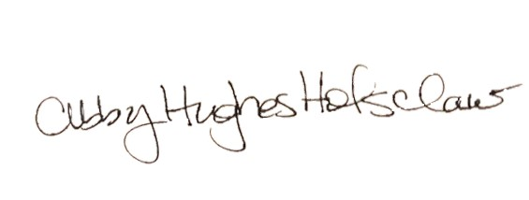
Abby Hughes Holsclaw, Secretary

