MINUTES OF THE MEETING
Arkansas Section 529 Plan Review Committee
Tuesday April 11, 2017 at 9:00am
Victory Building Conference Room, Suite 275 -- Little Rock, AR 72201

A meeting of the Arkansas Section 529 Plan Review Committee (“Committee”) was held on Tuesday, April 11, 2017 at 9:00 am in the Victory Building Conference Room, Suite 275. Present at the meeting were Treasurer Dennis Milligan; Grant Wallace with the Treasurer’s Office; Director of 529 Programs and Financial Education Emma Willis; AR 529 Assistant Lana Davis; Stacy Peterson with the Treasurer’s Office; Legal Counsel John Peace with Dover Dixon Horne, PLLC; Jonathan Coleman, serving as the voting representative for Dr. Markham with the Arkansas Department of Higher Education; Dave Ponder with Ascensus College Savings; John Park with BlackRock; Mary Ryan with Vanguard; Rod Graves, serving as the voting representative for Director George Hopkins with the Arkansas Teacher Retirement System; Kim Stockton and Matt Tufanno (via conference line) with Vanguard.

Grant Wallace confirmed the press was notified in compliance with the Freedom of Information Act.

Treasurer Milligan called the meeting to order at 9:00am. The minutes of the February 7, 2017 were approved with the motion made by Treasurer Milligan and seconded by Jonathan Coleman. The motion carried, and the minutes were approved.

Grant Wallace gave an update on the 2017 Legislative Session: House Bills 1473, 1762 and 1802 are now Acts 481,884 and 883 respectively. Act 547 was updated to add additional language and specific operations to the 529 Committee (Arkansas Tax Deferred Tuition Savings Program). HB1020 was pulled down to allow more time to work out details and funding.

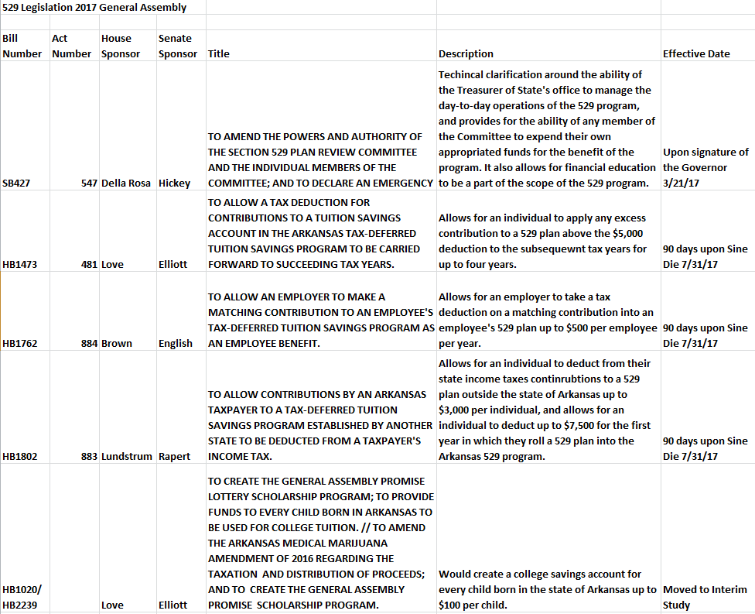

Emma Willis presented the FY2018 budget of $625,452.00, including marketing, initiatives, fees, travel, financial education and operational expenses. Graves moved to approve the FY2018 budget, and Coleman seconded. The budget was approved.
Willis then presented a FY2018 marketing proposal in the amount of $366,352.00 (which was included in above total of $625,452.00). This includes a contract to continue the partnership with Mangan Holcomb Partners (MHP) in the amount of $251,352.00 which allows them to handle all outreach, promotions, media, ads, radio and public relations. Coleman made a motion to approve the FY2018 marketing proposal, and Graves seconded. The proposal was approved.

John Peace reported on the FY2017 budget. As of 3/31/17 all three administrative accounts totaled $1,303,822.86. Total income was $454,885.30.

Emma Willis presented the checks and invoices for approval, which included Arkansas Travelers 2017 sponsorship, exhibit banner for Cinco de Mayo, CSPN annual fee, conference registration fees and travel reimbursements. Graves made a motion to pay all checks and invoices, Coleman seconded and the list was approved.

John Park with BlackRock reported the iShares 529 Plan assets as of April 2017 are $18.6 million and the average account size is $20,140.00. The first quarter of 2017 assets and sales totaled $369 million (assets), $15.8 million (sales). Park also provided an overview of where we stand today and how the company will continue to focus on future growth by increasing financial advisor awareness and distribution partners approved to sell the Arkansas 529 iShares plan.

Mary Ryan with Vanguard reviewed with the Committee an option which would allow a smoother glide path portfolio for the AR 529 GIFT Plan. Treasurer Milligan made a motion to approve the smoother glide path option, Graves seconded. The motion was approved.

Dave Ponder reported the GIFT plan assets as of March 31, 2017 are $359,299,687.00, contributions of $11.5 million, and withdrawals totaled $7 million. Funded accounts are 25,527, and the average funded account size is $14,076.00. Upromise rewards since inception totaled $1,327,892.00 and the Arkansas resident account owners linked total 3,194. UGift as of 3/31/17 totaled $2,374,250.00 (Gift Plan) and $620,142.00 (iShares529). Ponder also highlighted in February and March the total assets were above $350,000,000.00 if April stays the same a 4% BP reduction will be effective June 1, 2017.

The date for the 3rd Quarter meeting 2017 - TBD

There being no further business, Grant Wallace (serving as proxy for Treasurer Milligan) moved to adjourn and the meeting adjourned at 10:23.

Respectfully submitted,
Emma Willis, Director of 529 Programs and Financial Education

**Note – Minutes have not been approved by Committee.

